**Tăng cường độ chính xác**

1. Thay đổi tập ảnh datasets, tăng số lượng ảnh datasets cho mỗi tập lên, từ 15 ảnh đến 30-40 ảnh mỗi tập ảnh.
2. Tăng số lượng filter để trích xuất được nhiều đặc điểm của ảnh hơn
3. Tăng số lớp hidden từ 64 lên 128 lớp hidden, lớp output vẫn có 10 lớp như cũ, việc tăng lớp hidden sẽ giúp tăng độ chĩnh xác của model lên

Và kết quả:

*code:

model = Sequential()

model.add(Conv2D(32, kernel_size=3, activation='relu',input_shape=input_shape))

model.add(Conv2D(32, kernel_size=3, activation='relu'))

model.add(MaxPooling2D(pool_size=(2, 2)))

model.add(Conv2D(64, kernel_size=3, activation='relu'))

model.add(Conv2D(64, kernel_size=3, activation='relu'))

model.add(MaxPooling2D(pool_size=(2, 2)))

model.add(Conv2D(128, kernel_size=3, activation='relu'))

model.add(Flatten())

model.add(Dense(128, activation='relu'))

model.add(Dense(10, activation='softmax'))

Total params: 42,755,626

Trainable params: 42,755,626

Non-trainable params: 0

*training vẫn với 200 Epochs:

Epoch 1/200

8/8 [==============================] - 43s 5s/step - loss: 3.2747 - accuracy: 0.0656 - val_loss: 2.3422 - val_accuracy: 0.1000

Epoch 2/200

8/8 [==============================] - 36s 4s/step - loss: 2.2654 - accuracy: 0.1270 - val_loss: 2.3173 - val_accuracy: 0.1000

Epoch 3/200

8/8 [==============================] - 35s 4s/step - loss: 2.1530 - accuracy: 0.1926 - val_loss: 2.0865 - val_accuracy: 0.1000

Epoch 4/200

8/8 [==============================] - 36s 4s/step - loss: 2.1540 - accuracy: 0.1762 - val_loss: 2.2126 - val_accuracy: 0.3000

Epoch 5/200

8/8 [==============================] - 35s 4s/step - loss: 2.1787 - accuracy: 0.2131 - val_loss: 2.0458 - val_accuracy: 0.2000

Epoch 6/200

8/8 [==============================] - 35s 4s/step - loss: 2.0752 - accuracy: 0.2418 - val_loss: 1.9669 - val_accuracy: 0.2000

Epoch 7/200

8/8 [==============================] - 35s 4s/step - loss: 2.0054 - accuracy: 0.2172 - val_loss: 1.9666 - val_accuracy: 0.4000

Epoch 8/200

8/8 [==============================] - 35s 4s/step - loss: 2.0568 - accuracy: 0.1844 - val_loss: 1.9811 - val_accuracy: 0.4000

Epoch 9/200

8/8 [==============================] - 36s 4s/step - loss: 1.9141 - accuracy: 0.2787 - val_loss: 2.0476 - val_accuracy: 0.2000

Epoch 10/200

8/8 [==============================] - 35s 4s/step - loss: 1.9195 - accuracy: 0.2541 - val_loss: 1.9868 - val_accuracy: 0.2000

Epoch 11/200

8/8 [==============================] - 35s 4s/step - loss: 1.8908 - accuracy: 0.2828 - val_loss: 2.2364 - val_accuracy: 0.0000e+00

Epoch 12/200

8/8 [==============================] - 35s 4s/step - loss: 1.8544 - accuracy: 0.2459 - val_loss: 1.9908 - val_accuracy: 0.2000

Epoch 13/200

8/8 [==============================] - 35s 4s/step - loss: 1.8429 - accuracy: 0.2869 - val_loss: 2.2484 - val_accuracy: 0.2000

Epoch 14/200

8/8 [==============================] - 35s 5s/step - loss: 1.8139 - accuracy: 0.3156 - val_loss: 2.4702 - val_accuracy: 0.1000

Epoch 15/200

8/8 [==============================] - 35s 4s/step - loss: 1.8555 - accuracy: 0.2623 - val_loss: 2.0468 - val_accuracy: 0.2000

Epoch 16/200

8/8 [==============================] - 35s 4s/step - loss: 1.8679 - accuracy: 0.2582 - val_loss: 2.1003 - val_accuracy: 0.2000

Epoch 17/200

8/8 [==============================] - 35s 4s/step - loss: 1.8314 - accuracy: 0.2664 - val_loss: 2.0013 - val_accuracy: 0.3000

Epoch 18/200

8/8 [==============================] - 35s 4s/step - loss: 1.7180 - accuracy: 0.3156 - val_loss: 2.2753 - val_accuracy: 0.2000

Epoch 19/200

8/8 [==============================] - 35s 4s/step - loss: 1.8286 - accuracy: 0.2582 - val_loss: 2.3100 - val_accuracy: 0.2000

Epoch 20/200

8/8 [==============================] - 42s 5s/step - loss: 1.8347 - accuracy: 0.3033 - val_loss: 2.0469 - val_accuracy: 0.1000

Epoch 21/200

8/8 [==============================] - 42s 5s/step - loss: 1.7022 - accuracy: 0.3484 - val_loss: 2.0882 - val_accuracy: 0.3000

Epoch 22/200

8/8 [==============================] - 38s 5s/step - loss: 1.6337 - accuracy: 0.3361 - val_loss: 2.2726 - val_accuracy: 0.3000

Epoch 23/200

8/8 [==============================] - 36s 4s/step - loss: 1.6757 - accuracy: 0.3648 - val_loss: 1.8056 - val_accuracy: 0.3000

Epoch 24/200

8/8 [==============================] - 35s 4s/step - loss: 1.7219 - accuracy: 0.3607 - val_loss: 2.1259 - val_accuracy: 0.2000

Epoch 25/200

8/8 [==============================] - 35s 4s/step - loss: 1.7323 - accuracy: 0.3074 - val_loss: 2.0576 - val_accuracy: 0.2000

Epoch 26/200

8/8 [==============================] - 36s 5s/step - loss: 1.7130 - accuracy: 0.3238 - val_loss: 1.8781 - val_accuracy: 0.3000

Epoch 27/200

8/8 [==============================] - 36s 4s/step - loss: 1.5879 - accuracy: 0.4098 - val_loss: 1.4977 - val_accuracy: 0.4000

Epoch 28/200

8/8 [==============================] - 60s 8s/step - loss: 1.5108 - accuracy: 0.3852 - val_loss: 1.6450 - val_accuracy: 0.4000

Epoch 29/200

8/8 [==============================] - 82s 10s/step - loss: 1.4949 - accuracy: 0.4467 - val_loss: 1.9507 - val_accuracy: 0.2000

Epoch 30/200

8/8 [==============================] - 77s 10s/step - loss: 1.5143 - accuracy: 0.4016 - val_loss: 1.7593 - val_accuracy: 0.3000

Epoch 31/200

8/8 [==============================] - 81s 10s/step - loss: 1.3346 - accuracy: 0.4631 - val_loss: 1.7263 - val_accuracy: 0.4000

Epoch 32/200

8/8 [==============================] - 82s 10s/step - loss: 1.3993 - accuracy: 0.4959 - val_loss: 1.9310 - val_accuracy: 0.3000

Epoch 33/200

8/8 [==============================] - 77s 9s/step - loss: 1.4039 - accuracy: 0.4959 - val_loss: 1.6540 - val_accuracy: 0.3000

Epoch 34/200

8/8 [==============================] - 73s 9s/step - loss: 1.3729 - accuracy: 0.4467 - val_loss: 1.6519 - val_accuracy: 0.5000

Epoch 35/200

8/8 [==============================] - 75s 9s/step - loss: 1.2456 - accuracy: 0.5000 - val_loss: 1.7828 - val_accuracy: 0.3000

Epoch 36/200

8/8 [==============================] - 81s 10s/step - loss: 1.1938 - accuracy: 0.5492 - val_loss: 1.3503 - val_accuracy: 0.5000

Epoch 37/200

8/8 [==============================] - 85s 11s/step - loss: 1.2746 - accuracy: 0.5164 - val_loss: 2.1096 - val_accuracy: 0.4000

Epoch 38/200

8/8 [==============================] - 90s 11s/step - loss: 1.3013 - accuracy: 0.5082 - val_loss: 1.3958 - val_accuracy: 0.6000

Epoch 39/200

8/8 [==============================] - 88s 11s/step - loss: 1.2892 - accuracy: 0.4959 - val_loss: 1.5084 - val_accuracy: 0.5000

Epoch 40/200

8/8 [==============================] - 80s 10s/step - loss: 1.2497 - accuracy: 0.5574 - val_loss: 1.8195 - val_accuracy: 0.3000

Epoch 41/200

8/8 [==============================] - 85s 11s/step - loss: 1.2523 - accuracy: 0.5861 - val_loss: 1.3972 - val_accuracy: 0.7000

Epoch 42/200

8/8 [==============================] - 85s 10s/step - loss: 1.1374 - accuracy: 0.5451 - val_loss: 1.6535 - val_accuracy: 0.4000

Epoch 43/200

8/8 [==============================] - 81s 10s/step - loss: 1.1998 - accuracy: 0.5410 - val_loss: 1.7639 - val_accuracy: 0.3000

Epoch 44/200

8/8 [==============================] - 77s 10s/step - loss: 1.0969 - accuracy: 0.6148 - val_loss: 1.5076 - val_accuracy: 0.5000

Epoch 45/200

8/8 [==============================] - 84s 11s/step - loss: 1.0527 - accuracy: 0.5984 - val_loss: 1.5386 - val_accuracy: 0.7000

Epoch 46/200

8/8 [==============================] - 86s 11s/step - loss: 1.1066 - accuracy: 0.5656 - val_loss: 1.4866 - val_accuracy: 0.6000

Epoch 47/200

8/8 [==============================] - 90s 11s/step - loss: 1.1298 - accuracy: 0.5697 - val_loss: 1.3995 - val_accuracy: 0.7000

Epoch 48/200

8/8 [==============================] - 81s 11s/step - loss: 1.0249 - accuracy: 0.6475 - val_loss: 1.8825 - val_accuracy: 0.4000

Epoch 49/200

8/8 [==============================] - 81s 10s/step - loss: 1.0836 - accuracy: 0.5943 - val_loss: 1.7614 - val_accuracy: 0.2000

Epoch 50/200

8/8 [==============================] - 79s 10s/step - loss: 1.2111 - accuracy: 0.5533 - val_loss: 1.5766 - val_accuracy: 0.5000

Epoch 51/200

8/8 [==============================] - 80s 10s/step - loss: 1.0996 - accuracy: 0.6066 - val_loss: 1.6455 - val_accuracy: 0.4000

Epoch 52/200

8/8 [==============================] - 74s 9s/step - loss: 1.0117 - accuracy: 0.6230 - val_loss: 1.9577 - val_accuracy: 0.2000

Epoch 53/200

8/8 [==============================] - 78s 10s/step - loss: 1.0458 - accuracy: 0.6025 - val_loss: 1.6629 - val_accuracy: 0.5000

Epoch 54/200

8/8 [==============================] - 86s 11s/step - loss: 1.0810 - accuracy: 0.6066 - val_loss: 1.3885 - val_accuracy: 0.5000

Epoch 55/200

8/8 [==============================] - 85s 11s/step - loss: 1.0136 - accuracy: 0.6230 - val_loss: 1.8126 - val_accuracy: 0.4000

Epoch 56/200

8/8 [==============================] - 80s 10s/step - loss: 0.9489 - accuracy: 0.6803 - val_loss: 1.3442 - val_accuracy: 0.6000

Epoch 57/200

8/8 [==============================] - 82s 10s/step - loss: 1.0196 - accuracy: 0.6025 - val_loss: 1.6113 - val_accuracy: 0.6000

Epoch 58/200

8/8 [==============================] - 76s 9s/step - loss: 0.9803 - accuracy: 0.6066 - val_loss: 1.8554 - val_accuracy: 0.3000

Epoch 59/200

8/8 [==============================] - 74s 9s/step - loss: 1.0865 - accuracy: 0.5984 - val_loss: 1.6968 - val_accuracy: 0.5000

Epoch 60/200

8/8 [==============================] - 74s 10s/step - loss: 1.0001 - accuracy: 0.6270 - val_loss: 1.5811 - val_accuracy: 0.5000

Epoch 61/200

8/8 [==============================] - 79s 10s/step - loss: 0.9723 - accuracy: 0.6598 - val_loss: 1.2480 - val_accuracy: 0.6000

Epoch 62/200

8/8 [==============================] - 78s 10s/step - loss: 1.0095 - accuracy: 0.6270 - val_loss: 1.3761 - val_accuracy: 0.5000

Epoch 63/200

8/8 [==============================] - 75s 9s/step - loss: 0.9155 - accuracy: 0.6721 - val_loss: 1.5717 - val_accuracy: 0.5000

Epoch 64/200

8/8 [==============================] - 76s 9s/step - loss: 0.9348 - accuracy: 0.6598 - val_loss: 1.3995 - val_accuracy: 0.4000

Epoch 65/200

8/8 [==============================] - 76s 9s/step - loss: 0.9186 - accuracy: 0.6434 - val_loss: 1.5447 - val_accuracy: 0.6000

Epoch 66/200

8/8 [==============================] - 76s 9s/step - loss: 0.9701 - accuracy: 0.6393 - val_loss: 1.4083 - val_accuracy: 0.5000

Epoch 67/200

8/8 [==============================] - 73s 9s/step - loss: 0.9237 - accuracy: 0.6475 - val_loss: 1.6845 - val_accuracy: 0.5000

Epoch 68/200

8/8 [==============================] - 73s 9s/step - loss: 0.9146 - accuracy: 0.6475 - val_loss: 2.1981 - val_accuracy: 0.5000

Epoch 69/200

8/8 [==============================] - 79s 10s/step - loss: 0.8352 - accuracy: 0.6885 - val_loss: 1.7903 - val_accuracy: 0.3000

Epoch 70/200

8/8 [==============================] - 76s 9s/step - loss: 0.9603 - accuracy: 0.6230 - val_loss: 1.9864 - val_accuracy: 0.5000

Epoch 71/200

8/8 [==============================] - 73s 9s/step - loss: 0.9607 - accuracy: 0.6557 - val_loss: 1.8895 - val_accuracy: 0.6000

Epoch 72/200

8/8 [==============================] - 73s 9s/step - loss: 0.8649 - accuracy: 0.6557 - val_loss: 2.1790 - val_accuracy: 0.3000

Epoch 73/200

8/8 [==============================] - 78s 10s/step - loss: 1.0050 - accuracy: 0.6066 - val_loss: 2.1244 - val_accuracy: 0.4000

Epoch 74/200

8/8 [==============================] - 74s 9s/step - loss: 0.9068 - accuracy: 0.6475 - val_loss: 1.5558 - val_accuracy: 0.6000

Epoch 75/200

8/8 [==============================] - 73s 9s/step - loss: 0.8555 - accuracy: 0.6762 - val_loss: 1.6200 - val_accuracy: 0.6000

Epoch 76/200

8/8 [==============================] - 77s 10s/step - loss: 0.8938 - accuracy: 0.6721 - val_loss: 2.0100 - val_accuracy: 0.4000

Epoch 77/200

8/8 [==============================] - 81s 10s/step - loss: 0.9193 - accuracy: 0.6230 - val_loss: 1.5656 - val_accuracy: 0.4000

Epoch 78/200

8/8 [==============================] - 82s 10s/step - loss: 0.7799 - accuracy: 0.7213 - val_loss: 1.6312 - val_accuracy: 0.5000

Epoch 79/200

8/8 [==============================] - 74s 9s/step - loss: 0.9287 - accuracy: 0.6434 - val_loss: 2.7422 - val_accuracy: 0.5000

Epoch 80/200

8/8 [==============================] - 81s 10s/step - loss: 0.9100 - accuracy: 0.6639 - val_loss: 1.6636 - val_accuracy: 0.5000

Epoch 81/200

8/8 [==============================] - 78s 10s/step - loss: 0.9027 - accuracy: 0.6516 - val_loss: 1.3359 - val_accuracy: 0.5000

Epoch 82/200

8/8 [==============================] - 68s 8s/step - loss: 0.8462 - accuracy: 0.7172 - val_loss: 1.4114 - val_accuracy: 0.5000

Epoch 83/200

8/8 [==============================] - 63s 8s/step - loss: 0.9394 - accuracy: 0.6311 - val_loss: 1.6476 - val_accuracy: 0.5000

Epoch 84/200

8/8 [==============================] - 63s 8s/step - loss: 0.8172 - accuracy: 0.6885 - val_loss: 1.7927 - val_accuracy: 0.4000

Epoch 85/200

8/8 [==============================] - 65s 8s/step - loss: 0.8245 - accuracy: 0.6721 - val_loss: 2.2638 - val_accuracy: 0.2000

Epoch 86/200

8/8 [==============================] - 66s 9s/step - loss: 0.7717 - accuracy: 0.7418 - val_loss: 1.7993 - val_accuracy: 0.5000

Epoch 87/200

8/8 [==============================] - 64s 8s/step - loss: 0.7548 - accuracy: 0.7418 - val_loss: 1.9535 - val_accuracy: 0.5000

Epoch 88/200

8/8 [==============================] - 67s 8s/step - loss: 0.7687 - accuracy: 0.6967 - val_loss: 1.7755 - val_accuracy: 0.3000

Epoch 89/200

8/8 [==============================] - 65s 8s/step - loss: 0.6872 - accuracy: 0.7582 - val_loss: 2.3532 - val_accuracy: 0.5000

Epoch 90/200

8/8 [==============================] - 64s 8s/step - loss: 0.7576 - accuracy: 0.7295 - val_loss: 1.1683 - val_accuracy: 0.5000

Epoch 91/200

8/8 [==============================] - 64s 8s/step - loss: 0.7933 - accuracy: 0.6926 - val_loss: 1.6847 - val_accuracy: 0.5000

Epoch 92/200

8/8 [==============================] - 70s 8s/step - loss: 1.1250 - accuracy: 0.6107 - val_loss: 2.0188 - val_accuracy: 0.5000

Epoch 93/200

8/8 [==============================] - 65s 8s/step - loss: 0.9585 - accuracy: 0.6639 - val_loss: 1.4074 - val_accuracy: 0.5000

Epoch 94/200

8/8 [==============================] - 73s 9s/step - loss: 0.9719 - accuracy: 0.6926 - val_loss: 1.5743 - val_accuracy: 0.6000

Epoch 95/200

8/8 [==============================] - 66s 8s/step - loss: 0.8634 - accuracy: 0.6762 - val_loss: 1.6170 - val_accuracy: 0.5000

Epoch 96/200

8/8 [==============================] - 65s 8s/step - loss: 0.7838 - accuracy: 0.7336 - val_loss: 1.7897 - val_accuracy: 0.5000

Epoch 97/200

8/8 [==============================] - 66s 8s/step - loss: 0.7268 - accuracy: 0.7213 - val_loss: 1.6606 - val_accuracy: 0.6000

Epoch 98/200

8/8 [==============================] - 67s 9s/step - loss: 0.7727 - accuracy: 0.7131 - val_loss: 2.0842 - val_accuracy: 0.3000

Epoch 99/200

8/8 [==============================] - 64s 8s/step - loss: 0.7072 - accuracy: 0.7213 - val_loss: 1.5437 - val_accuracy: 0.5000

Epoch 100/200

8/8 [==============================] - 64s 8s/step - loss: 0.8976 - accuracy: 0.6680 - val_loss: 1.5531 - val_accuracy: 0.5000

Epoch 101/200

8/8 [==============================] - 63s 8s/step - loss: 0.7770 - accuracy: 0.6844 - val_loss: 1.4532 - val_accuracy: 0.5000

Epoch 102/200

8/8 [==============================] - 63s 8s/step - loss: 0.6865 - accuracy: 0.7582 - val_loss: 1.8964 - val_accuracy: 0.5000

Epoch 103/200

8/8 [==============================] - 84s 10s/step - loss: 0.8225 - accuracy: 0.6598 - val_loss: 2.5093 - val_accuracy: 0.3000

Epoch 104/200

8/8 [==============================] - 71s 9s/step - loss: 0.7004 - accuracy: 0.7623 - val_loss: 1.4745 - val_accuracy: 0.6000

Epoch 105/200

8/8 [==============================] - 75s 9s/step - loss: 0.6515 - accuracy: 0.7500 - val_loss: 1.8218 - val_accuracy: 0.4000

Epoch 106/200

8/8 [==============================] - 66s 9s/step - loss: 0.6420 - accuracy: 0.7500 - val_loss: 1.3894 - val_accuracy: 0.6000

Epoch 107/200

8/8 [==============================] - 76s 10s/step - loss: 0.6006 - accuracy: 0.7787 - val_loss: 1.5231 - val_accuracy: 0.7000

Epoch 108/200

8/8 [==============================] - 66s 8s/step - loss: 0.6199 - accuracy: 0.7787 - val_loss: 1.8056 - val_accuracy: 0.6000

Epoch 109/200

8/8 [==============================] - 64s 8s/step - loss: 0.6943 - accuracy: 0.7459 - val_loss: 1.6620 - val_accuracy: 0.7000

Epoch 110/200

8/8 [==============================] - 70s 8s/step - loss: 0.7254 - accuracy: 0.7295 - val_loss: 2.4531 - val_accuracy: 0.5000

Epoch 111/200

8/8 [==============================] - 64s 8s/step - loss: 0.7788 - accuracy: 0.7336 - val_loss: 2.0027 - val_accuracy: 0.5000

Epoch 112/200

8/8 [==============================] - 64s 8s/step - loss: 0.7534 - accuracy: 0.7131 - val_loss: 1.2917 - val_accuracy: 0.5000

Epoch 113/200

8/8 [==============================] - 64s 8s/step - loss: 0.7872 - accuracy: 0.6885 - val_loss: 1.5856 - val_accuracy: 0.6000

Epoch 114/200

8/8 [==============================] - 63s 8s/step - loss: 0.7078 - accuracy: 0.7418 - val_loss: 1.7845 - val_accuracy: 0.5000

Epoch 115/200

8/8 [==============================] - 62s 8s/step - loss: 0.7803 - accuracy: 0.7336 - val_loss: 1.9802 - val_accuracy: 0.4000

Epoch 116/200

8/8 [==============================] - 64s 8s/step - loss: 0.6860 - accuracy: 0.7418 - val_loss: 1.9443 - val_accuracy: 0.5000

Epoch 117/200

8/8 [==============================] - 66s 8s/step - loss: 0.6989 - accuracy: 0.7459 - val_loss: 0.9817 - val_accuracy: 0.7000

Epoch 118/200

Epoch 123/200

8/8 [==============================] - 68s 8s/step - loss: 0.5947 - accuracy: 0.8033 - val_loss: 1.3876 - val_accuracy: 0.6000

Epoch 124/200

8/8 [==============================] - 64s 8s/step - loss: 0.7154 - accuracy: 0.7336 - val_loss: 1.7501 - val_accuracy: 0.3000

Epoch 125/200

8/8 [==============================] - 65s 8s/step - loss: 0.7213 - accuracy: 0.7746 - val_loss: 2.2537 - val_accuracy: 0.6000

Epoch 126/200

8/8 [==============================] - 68s 8s/step - loss: 0.7583 - accuracy: 0.7090 - val_loss: 1.5518 - val_accuracy: 0.5000

Epoch 127/200

8/8 [==============================] - 64s 8s/step - loss: 0.6148 - accuracy: 0.7623 - val_loss: 1.9128 - val_accuracy: 0.7000

Epoch 128/200

8/8 [==============================] - 67s 8s/step - loss: 0.5501 - accuracy: 0.7910 - val_loss: 2.0636 - val_accuracy: 0.4000

Epoch 129/200

8/8 [==============================] - 63s 8s/step - loss: 0.5725 - accuracy: 0.7869 - val_loss: 1.3438 - val_accuracy: 0.7000

Epoch 130/200

8/8 [==============================] - 66s 8s/step - loss: 0.4914 - accuracy: 0.8320 - val_loss: 1.6413 - val_accuracy: 0.6000

Epoch 131/200

8/8 [==============================] - 64s 8s/step - loss: 0.4965 - accuracy: 0.8402 - val_loss: 2.0074 - val_accuracy: 0.6000

Epoch 132/200

8/8 [==============================] - 110s 14s/step - loss: 0.5384 - accuracy: 0.8033 - val_loss: 2.2837 - val_accuracy: 0.3000

Epoch 133/200

8/8 [==============================] - 81s 9s/step - loss: 0.6058 - accuracy: 0.7787 - val_loss: 1.9408 - val_accuracy: 0.5000

Epoch 134/200

8/8 [==============================] - 73s 9s/step - loss: 0.6219 - accuracy: 0.7459 - val_loss: 2.1670 - val_accuracy: 0.3000

Epoch 135/200

8/8 [==============================] - 70s 9s/step - loss: 0.4983 - accuracy: 0.7910 - val_loss: 1.8395 - val_accuracy: 0.6000

Epoch 136/200

8/8 [==============================] - 69s 9s/step - loss: 0.4354 - accuracy: 0.8361 - val_loss: 2.6595 - val_accuracy: 0.4000

Epoch 137/200

8/8 [==============================] - 63s 8s/step - loss: 0.4648 - accuracy: 0.8279 - val_loss: 1.3159 - val_accuracy: 0.6000

Epoch 138/200

8/8 [==============================] - 65s 8s/step - loss: 0.6508 - accuracy: 0.7746 - val_loss: 1.4572 - val_accuracy: 0.6000

Epoch 139/200

8/8 [==============================] - 36s 4s/step - loss: 0.7312 - accuracy: 0.7254 - val_loss: 1.8081 - val_accuracy: 0.6000

Epoch 140/200

8/8 [==============================] - 35s 4s/step - loss: 0.5842 - accuracy: 0.7664 - val_loss: 1.8996 - val_accuracy: 0.6000

Epoch 141/200

8/8 [==============================] - 35s 4s/step - loss: 0.5496 - accuracy: 0.7910 - val_loss: 1.7146 - val_accuracy: 0.5000

Epoch 142/200

8/8 [==============================] - 35s 4s/step - loss: 0.5064 - accuracy: 0.8238 - val_loss: 1.7145 - val_accuracy: 0.6000

Epoch 143/200

8/8 [==============================] - 35s 4s/step - loss: 0.5798 - accuracy: 0.8033 - val_loss: 2.6029 - val_accuracy: 0.5000

Epoch 144/200

8/8 [==============================] - 35s 4s/step - loss: 0.5127 - accuracy: 0.8074 - val_loss: 2.4702 - val_accuracy: 0.5000

Epoch 145/200

8/8 [==============================] - 36s 4s/step - loss: 0.5518 - accuracy: 0.8074 - val_loss: 1.5426 - val_accuracy: 0.7000

Epoch 146/200

8/8 [==============================] - 35s 4s/step - loss: 0.4981 - accuracy: 0.8156 - val_loss: 1.8186 - val_accuracy: 0.5000

Epoch 147/200

8/8 [==============================] - 35s 4s/step - loss: 0.5724 - accuracy: 0.7746 - val_loss: 2.2616 - val_accuracy: 0.5000

Epoch 148/200

8/8 [==============================] - 35s 4s/step - loss: 0.5370 - accuracy: 0.7828 - val_loss: 1.8470 - val_accuracy: 0.6000

Epoch 149/200

8/8 [==============================] - 35s 4s/step - loss: 0.6243 - accuracy: 0.7582 - val_loss: 2.2848 - val_accuracy: 0.5000

Epoch 150/200

8/8 [==============================] - 34s 4s/step - loss: 0.6022 - accuracy: 0.7910 - val_loss: 2.0119 - val_accuracy: 0.4000

Epoch 151/200

8/8 [==============================] - 34s 4s/step - loss: 0.5947 - accuracy: 0.7869 - val_loss: 2.3747 - val_accuracy: 0.4000

Epoch 152/200

8/8 [==============================] - 35s 4s/step - loss: 0.4449 - accuracy: 0.8361 - val_loss: 2.4011 - val_accuracy: 0.4000

Epoch 153/200

8/8 [==============================] - 35s 4s/step - loss: 0.5176 - accuracy: 0.8361 - val_loss: 2.1015 - val_accuracy: 0.6000

Epoch 154/200

8/8 [==============================] - 35s 4s/step - loss: 0.5440 - accuracy: 0.7910 - val_loss: 1.5312 - val_accuracy: 0.8000

Epoch 155/200

8/8 [==============================] - 37s 5s/step - loss: 0.4730 - accuracy: 0.8156 - val_loss: 2.0691 - val_accuracy: 0.6000

Epoch 156/200

8/8 [==============================] - 35s 4s/step - loss: 0.5529 - accuracy: 0.7951 - val_loss: 2.5864 - val_accuracy: 0.4000

Epoch 157/200

8/8 [==============================] - 35s 4s/step - loss: 0.5519 - accuracy: 0.8074 - val_loss: 2.6254 - val_accuracy: 0.5000

Epoch 158/200

8/8 [==============================] - 35s 4s/step - loss: 0.4459 - accuracy: 0.8361 - val_loss: 1.7896 - val_accuracy: 0.8000

Epoch 159/200

8/8 [==============================] - 35s 4s/step - loss: 0.4439 - accuracy: 0.8402 - val_loss: 2.0543 - val_accuracy: 0.6000

Epoch 160/200

8/8 [==============================] - 35s 4s/step - loss: 0.5943 - accuracy: 0.7746 - val_loss: 1.2136 - val_accuracy: 0.7000

Epoch 161/200

8/8 [==============================] - 35s 4s/step - loss: 0.5556 - accuracy: 0.7910 - val_loss: 1.8647 - val_accuracy: 0.6000

Epoch 162/200

8/8 [==============================] - 35s 4s/step - loss: 0.6061 - accuracy: 0.7992 - val_loss: 2.4442 - val_accuracy: 0.5000

Epoch 163/200

8/8 [==============================] - 35s 4s/step - loss: 0.5634 - accuracy: 0.7869 - val_loss: 2.5904 - val_accuracy: 0.4000

Epoch 164/200

8/8 [==============================] - 35s 4s/step - loss: 0.5629 - accuracy: 0.7910 - val_loss: 2.2657 - val_accuracy: 0.6000

Epoch 165/200

8/8 [==============================] - 35s 4s/step - loss: 0.4880 - accuracy: 0.7664 - val_loss: 1.8226 - val_accuracy: 0.6000

Epoch 166/200

8/8 [==============================] - 35s 4s/step - loss: 0.5596 - accuracy: 0.7869 - val_loss: 2.5422 - val_accuracy: 0.6000

Epoch 167/200

8/8 [==============================] - 34s 4s/step - loss: 0.5406 - accuracy: 0.7951 - val_loss: 2.4165 - val_accuracy: 0.3000

Epoch 168/200

8/8 [==============================] - 35s 4s/step - loss: 0.5262 - accuracy: 0.8033 - val_loss: 1.7662 - val_accuracy: 0.5000

Epoch 169/200

8/8 [==============================] - 35s 4s/step - loss: 0.4339 - accuracy: 0.8279 - val_loss: 1.8057 - val_accuracy: 0.3000

Epoch 170/200

8/8 [==============================] - 34s 4s/step - loss: 0.5025 - accuracy: 0.8115 - val_loss: 1.8308 - val_accuracy: 0.7000

Epoch 171/200

8/8 [==============================] - 35s 4s/step - loss: 0.5136 - accuracy: 0.8115 - val_loss: 2.6837 - val_accuracy: 0.3000

Epoch 172/200

8/8 [==============================] - 35s 4s/step - loss: 0.4561 - accuracy: 0.8279 - val_loss: 1.1627 - val_accuracy: 0.7000

Epoch 173/200

8/8 [==============================] - 35s 4s/step - loss: 0.4779 - accuracy: 0.8402 - val_loss: 1.7659 - val_accuracy: 0.8000

Epoch 174/200

8/8 [==============================] - 35s 4s/step - loss: 0.4956 - accuracy: 0.7869 - val_loss: 2.8208 - val_accuracy: 0.5000

Epoch 175/200

8/8 [==============================] - 37s 5s/step - loss: 0.4975 - accuracy: 0.7746 - val_loss: 2.0280 - val_accuracy: 0.4000

Epoch 176/200

8/8 [==============================] - 36s 4s/step - loss: 0.6365 - accuracy: 0.7623 - val_loss: 2.5348 - val_accuracy: 0.4000

Epoch 177/200

8/8 [==============================] - 37s 4s/step - loss: 0.6647 - accuracy: 0.7910 - val_loss: 1.9425 - val_accuracy: 0.6000

Epoch 178/200

8/8 [==============================] - 36s 4s/step - loss: 0.5722 - accuracy: 0.7828 - val_loss: 1.8079 - val_accuracy: 0.5000

Epoch 179/200

8/8 [==============================] - 36s 4s/step - loss: 0.4348 - accuracy: 0.8484 - val_loss: 2.3014 - val_accuracy: 0.6000

Epoch 180/200

8/8 [==============================] - 35s 4s/step - loss: 0.5525 - accuracy: 0.7910 - val_loss: 2.6052 - val_accuracy: 0.5000

Epoch 181/200

8/8 [==============================] - 35s 4s/step - loss: 0.6853 - accuracy: 0.7254 - val_loss: 1.3250 - val_accuracy: 0.8000

Epoch 182/200

8/8 [==============================] - 35s 4s/step - loss: 0.4391 - accuracy: 0.8402 - val_loss: 2.1243 - val_accuracy: 0.4000

Epoch 183/200

8/8 [==============================] - 35s 4s/step - loss: 0.5471 - accuracy: 0.7869 - val_loss: 1.6835 - val_accuracy: 0.5000

Epoch 184/200

8/8 [==============================] - 35s 4s/step - loss: 0.4822 - accuracy: 0.8320 - val_loss: 1.8287 - val_accuracy: 0.5000

Epoch 185/200

8/8 [==============================] - 35s 4s/step - loss: 0.5384 - accuracy: 0.7992 - val_loss: 1.6091 - val_accuracy: 0.5000

Epoch 186/200

8/8 [==============================] - 35s 4s/step - loss: 0.5357 - accuracy: 0.8238 - val_loss: 1.3295 - val_accuracy: 0.7000

Epoch 187/200

8/8 [==============================] - 34s 4s/step - loss: 0.4520 - accuracy: 0.8320 - val_loss: 2.1516 - val_accuracy: 0.5000

Epoch 188/200

8/8 [==============================] - 34s 4s/step - loss: 0.4665 - accuracy: 0.8402 - val_loss: 1.7768 - val_accuracy: 0.5000

Epoch 189/200

8/8 [==============================] - 35s 4s/step - loss: 0.4563 - accuracy: 0.8525 - val_loss: 1.3047 - val_accuracy: 0.6000

Epoch 190/200

8/8 [==============================] - 35s 4s/step - loss: 0.3919 - accuracy: 0.8484 - val_loss: 1.9343 - val_accuracy: 0.6000

Epoch 191/200

8/8 [==============================] - 35s 4s/step - loss: 0.4813 - accuracy: 0.8648 - val_loss: 2.0198 - val_accuracy: 0.6000

Epoch 192/200

8/8 [==============================] - 35s 4s/step - loss: 0.3847 - accuracy: 0.8607 - val_loss: 2.3541 - val_accuracy: 0.5000

Epoch 193/200

8/8 [==============================] - 35s 4s/step - loss: 0.3185 - accuracy: 0.8811 - val_loss: 2.7959 - val_accuracy: 0.6000

Epoch 194/200

8/8 [==============================] - 35s 4s/step - loss: 0.3910 - accuracy: 0.8074 - val_loss: 1.6708 - val_accuracy: 0.7000

Epoch 195/200

8/8 [==============================] - 35s 4s/step - loss: 0.4307 - accuracy: 0.8361 - val_loss: 1.8343 - val_accuracy: 0.5000

Epoch 196/200

8/8 [==============================] - 35s 4s/step - loss: 0.3432 - accuracy: 0.8893 - val_loss: 2.8786 - val_accuracy: 0.5000

Epoch 197/200

8/8 [==============================] - 35s 4s/step - loss: 0.4121 - accuracy: 0.8648 - val_loss: 1.5811 - val_accuracy: 0.6000

Epoch 198/200

8/8 [==============================] - 35s 4s/step - loss: 0.6529 - accuracy: 0.8033 - val_loss: 2.0742 - val_accuracy: 0.6000

Epoch 199/200

8/8 [==============================] - 35s 4s/step - loss: 0.7487 - accuracy: 0.7500 - val_loss: 1.5548 - val_accuracy: 0.6000

Epoch 200/200

8/8 [==============================] - 35s 4s/step - loss: 0.5902 - accuracy: 0.7664 - val_loss: 2.1175 - val_accuracy: 0.4000

Độ chính xác lớn nhất đạt là 89%

Giải thích thắc mắc tuần trước:

Trong mạng CNN có nhiều kiến trúc khác nhau trong đó VGG là một trong những kiến trúc của mạng CNN, VGG sẽ được cải tiến hơn so với các mạng kiến trúc trước đó của CNN như LeNet và AlexNet, là nếu hai cái sau sẽ kết hợp 1 lớp Conv sau đó là 1 lớp Maxpooling thành cặp Conv-MaxPool, thì VGG sẽ sử dụng liên tiếp 2 lần Conv rồi mới dùng lớp MaxPooling thành cặp Conv-Conv, hoặc cũng có thể là 3 lần Conv liên tiếp với nhau, và tất cả các bộ lọc đều có kích thức là (3x3) .Điều này làm việc tính toán trở nên lâu hơn (train lâu hơn), nhưng cái lợi của nó là giữ được nhiều feature hơn so với hai lớp trước kia.

Từ khi VGG-Net được ra đời, kiến trúc này dùng nhiều cho việc nhận diện khuôn mặt từ đó kiến trúc VGG-Face ra đời dựa trên cấu trúc của mạng VGG-16

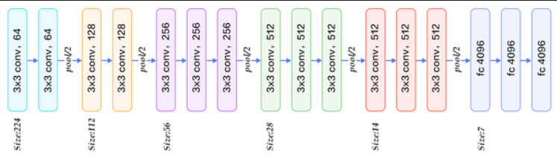

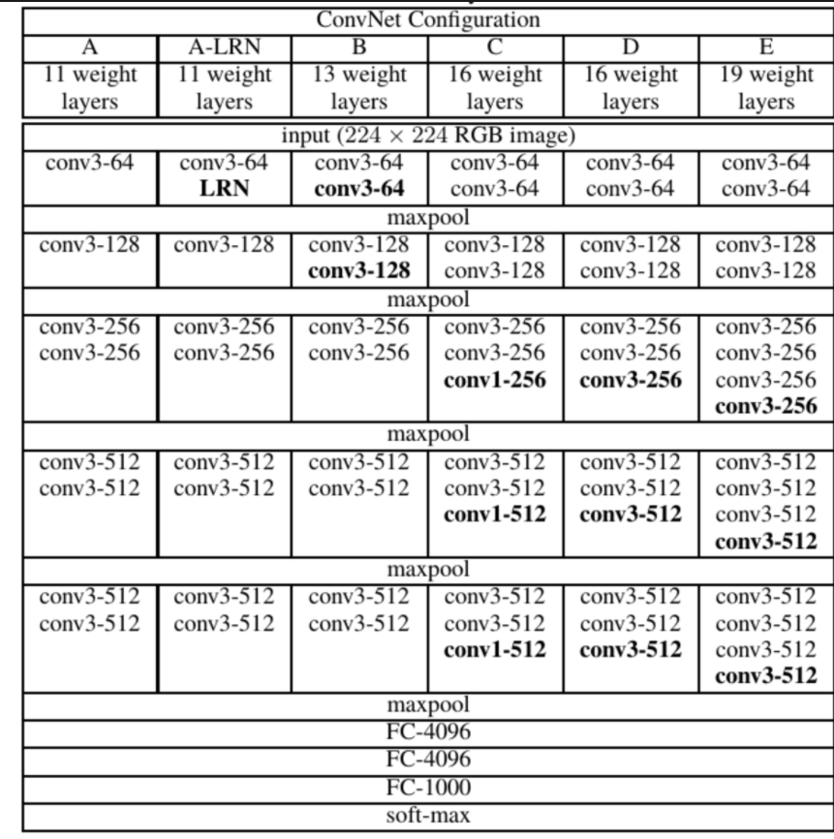

Kiến trúc VGG-Face được github xây dựng

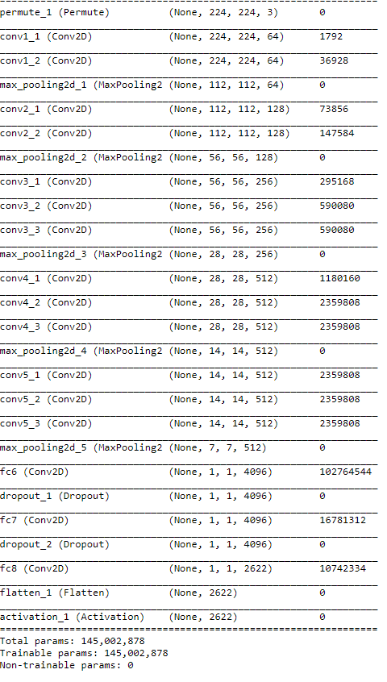

The VGG achieves the top-5 accuracy of 92.3 % on ImageNet

VGG-Face là tập hợp các mạng CNN phổ biến hiện nay dùng khá nhiều cho nhận diện khuôn mặt đó là VGG16, Senet50, Resnet50

Các lớp filter bên trong của VGG:

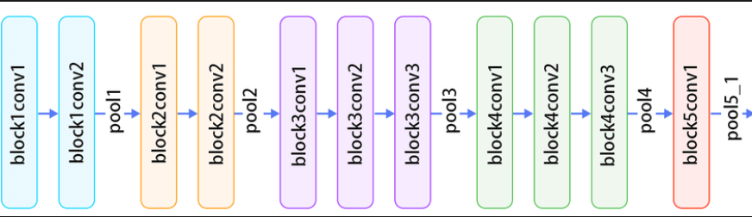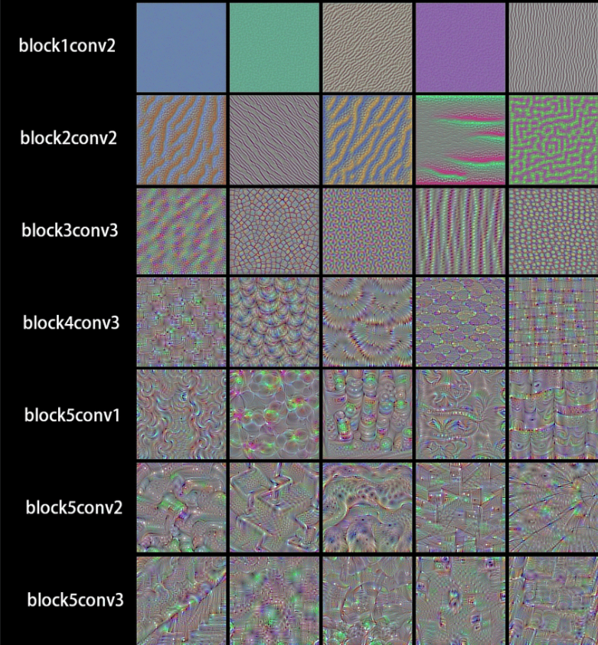

Tuần này:

Cân bằng sáng, tiền xử lý ảnh